Inge Becht 6093906

NS Lab Assignment

IP Addressing and BGP Routing
Chariklis Pittaras (c.pittaras@uva.nl)
Karel van der Veldt (karel.vd.veldt@uva.nl)
Lab date: Nov 23, 2012
Hand-in time (submit to blackboard) by Nov 26, 2012 23:59CEST
Total points: 10 pts
Abstract
This assignment focuses on the BGP routing and IP addressing.

Task 1 – IPv4 addressing (3 pts)
In this task you are going to practice IPv4 addressing. You have the IPv4 address space A.B.0.0/15, where A = length(<first name>) and B = 2*length(<last name>).
Write your address space here: 4.10.0.0/15.
Answer the following questions; for every question explain how you obtained the given result and provide all the calculations that you did.

Questions:
- If you split your address space into subnets of /23, (a) how many subnets you have? (b) How many IP addresses does each subnet have? (c) What is the maximum number of the hosts (including routers interfaces) that each subnet can have?
  - 23 – 15 = 8 bits that can be varied for each subnet, giving 2^8 = 256 different subnets.
  - 32 – 23 = 9 bits free for each subset, so that 2^9 = 512 different ip addresses per subnet
  - we cannot set the bit to all 1s (broadcast address) or to all 0s so 512- 510

- For the first /23 subnet, give (a) the network and (b) the broadcast IP:
  - The first is setting all bits in the subnet to 0:
4.10.0/23
  - All of the 9 free bits are set to one, giving:
0000 0100. 0000 1010. 0000 0001. 1111 1111
or : 4.10.1.255

- For the 130th /23 subnet, give (a) the network and (b) the broadcast IP:
  - 00000100.0000101|x.xxxxxxx|X/23 The x's are the bits to be
used, the X indicates that this bit no longer belongs to the subnet the 130th subnet is number 129 which in binary is 10000001. So fill this in: 00000100.0000101|1.0000001|X/23
This is the same as ip = 4.11.1/23
  - setting all bits to 1 again outside of the 23 fixed bits:
00000100.00001011.00000011.11111111
or: 4.11.3.255

Task 2 – IPv6 addressing (2 pts)
In this task you are going to practice IPv6 addressing. You have the IPv6 address space 2001:0db8:XX00:YY00::/58, where X = (length(<first name>)*3) mod 16 and Y = (length(<last name>)*3) mod 16.
Write your address space here: 2001:0db8:CC00:FF00::/58.
Answer the following questions; for every question explain how you obtained the given result and provide all the calculation that you did.

Questions:
- (a) Give the total address range? (b) How many /64 subnets do you have? (c) How many addresses each subnet has?
  - 128-58 = 70 bits free for addresses. This gives 2^70 free different addresses
  - 64 – 58 = 6 free bits for subnets gives 2^6 = 64 different subnets
  - For every subnet 64 bits are already used for the mask so 2^64 different addresses

- Give the IP address of the 2nd/64 subnet.
To give an idea which bits are usable for the subnet I wrote everything to bits:
0010 0000 0000 0001: 0000 1101 1011 1000: 1100 1100 0000 0000 : 1111 1111 00XX XXXX/64 where X are the bits usable for the subnet. The first subnet is ofcourse making all these bits 0, so the second subnet corresponds with the number 1 and gives
0010 0000 0000 0001: 0000 1101 1011 1000: 1100 1100 0000 0000 : 1111 1111 0000 0001/64 which in hexadecimal = 2001:0db8:CC00:FF01:/64.

- Give the IP address of the 42nd/64 subnet.
The 42^nd subnet corresponds with number 41 so in binary this becomes
0010 0000 0000 0001: 0000 1101 1011 1000: 1100 1100 0000 0000 : 1111 1111 0010 1010/64
in hexidecimal: 2001:0db8:CC00:FF2A:/64.

Task 3 – Find the Path (5 pts)
We are going to use BGP Looking Glass servers to find out what the path is that BGP routers use to reach a specific destination.
BGP Looking Glass servers are computers on the Internet running one of a variety of publicly available Looking Glass software implementations. A Looking Glass server (or LG server) is accessed remotely for the purpose of viewing routing info. Essentially, the server acts as a limited, read-only portal to routers of whatever organization is running the Looking Glass server. Typically, publicly accessible looking glass servers are run by ISPs or NOCs. [1]
From the looking glasses (LG) server listed at: http://www.bgp4.as/looking-glasses, choose one from Netherlands, two from Europe, one from USA and one from Japan. For each one look at the BGP routes to the University of Amsterdam (146.50.0.0/16).

Questions:
- For each LG server, find the first given BGP path to the UvA. Make one figure indicating the AS paths between the LG servers (that you chose before) and the UvA. For each LG server, write down, its AS number and website.
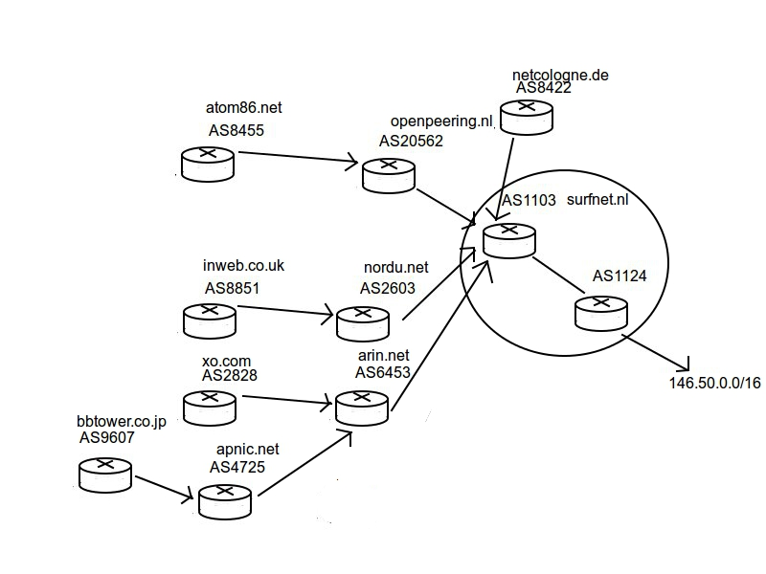

- Fill the following table, presenting the AS names, that you have in your figure. To find out the AS name use the website https://apps.db.ripe.net/search/query.html or http://asn.cymru.com/cgi-bin/whois.cgi (note: in the query field provide the AS number with the ‘AS’ in front of the number. i.e. AS7458)
 | AS Number | Country | AS Name
1 | AS8455 | Netherlands | ATOM86-AS
2 | AS8422 | Germany | NETCOLOGNE
3 | AS8551 | United Kingdom | EDGE
4 | AS2828 | USA | XO-AS15
5 | AS9607 | Japan | JPNIC-NET-JP-AS-BLOCK

Submission
You have to submit:
- Your answers to all the questions. Use this document for you answers and provide your answers in the appropriate answer field for each question
- The figure for question 7
- The table for question 8
Attention: You have to submit one PDF file that contains all the answers; the name of the file should be lab7-<lastnamefirstletter>.pdf (example: lab7-vanderveldtk.pdf, or lab7-pittarasc.pdf).
Any other kind of submission will not be taken into account. You must also put your full name and your student number at the top of the file

References
[1] http://www.bgp4.as/looking-glasses

